**Experiment 3.1**

**Aim:** To write python program to Implement different types of exceptions.

**Solution:**

Classes and Objects

class Person:

def __init__(self, name):

self.name = name

def whoami(self):

return "You are " + self.name

p1 = Person('Abhishek')

print(p1.whoami())

print(p1.name)



Static Method

class Mathematics:

def addNumbers(x, y):

return x + y

Mathematics.addNumbers = staticmethod(Mathematics.addNumbers)

print('The sum is:', Mathematics.addNumbers(5, 10))

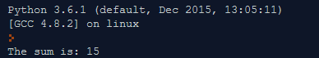

Inner Classes

class Human:

def __init__(self):

self.name = 'Guido'

self.head = self.Head()

class Head:

def talk(self):

return 'talking...'

if __name__ == '__main__':

guido = Human()

print guido.name

print guido.head.talk()

